Here is the screenshot of the dashboard option for Aweber Wordpress Plugin:

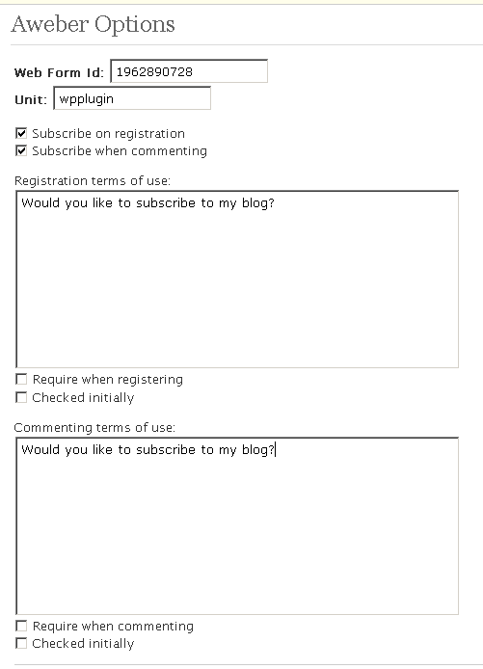
1
2
3
4

The Webform ID & Unit can be obtained from your Aweber webform HTML code:
1

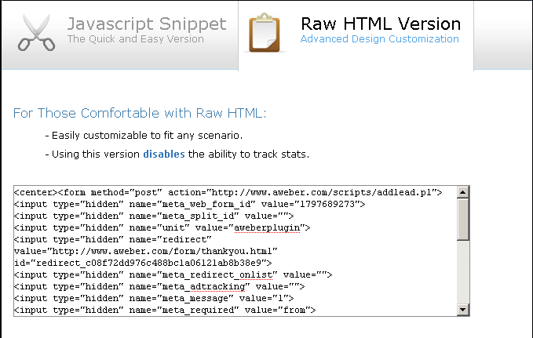
2

Checkbox the desired opt-in setting. You can subscribe the user upon registration and/or commenting.

3
If "Subscribe on registration" is checked (in 2), this is the text (along with a checkbox) that will be displayed above the registration submission button.

Check "Require during registering" if the user must click on the checkbox, otherwise he/she can't register to your blog.

Check "Checked initially" if you want the checkbox to be checked when displaying for the first time.

4
If "Subscribe when commenting" is checked (in 2), this is the text (along with a checkbox) that will be displayed above the comment submission button.

Check "Require when commenting" if the user must click on the checkbox, otherwise he/she can't comment on your blog.

Check "Checked initially" if you want the checkbox to be checked when displaying for the first time.

